
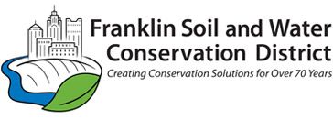
2026 – 2027 WATERSHED PARTNERSHIP SERVICE AGREEMENT
APPLICATION LANDOWNER ACKNOWLEDGEMENT FORM

I, ___________________________________, landowner of parcel #______________,
located at ____________________________________________________________,
hereby grant express consent to ___________________________________ to access and use this property for the activities described in the 2025–2026 Watershed Partnership Service Agreement application submitted by ____________________.
By signing below, the landowner and project manager confirm that we have reviewed and approved the final proposal in its entirety and agree to fulfill all duties and responsibilities explicitly and implicitly outlined therein.

Signature:

________________________________________________________________
Landowner Printed Name Landowner Phone Number

________________________________________________________________
Landowner Signature Landowner Email Address

________________________________________________________________
Organization Name Authorized Signature

